Hurricane 5.9 - Proposal to Increase Mainsheet Purchase to 10:1
Load Tests Undertaken by John Donovan, Nov ‘21 – Apr ‘22

Introduction and Background
At the 2021 AGM, Jack Tindale asked if the Association would allow the maximum mainsheet purchase to be increased from the current maximum of 9:1 purchase to 10:1, which would reduce the sheet load. The matter was deferred to the ‘Rules and Technical Committee’ for further investigation and discussion.

Having done tests on the 9:1 system and developed a low-cost modification to the original 7:1, I was asked to look into the benefits and problems that the modification would bring.

The testing has been expanded to include purchase ratios from 7:1 to 10:1, using the variety of equipment currently in use, together with the newly introduced Allen 60mm diameter blocks. It was felt that the information would be useful to the class, as it’s not something that manufacturers currently publish.

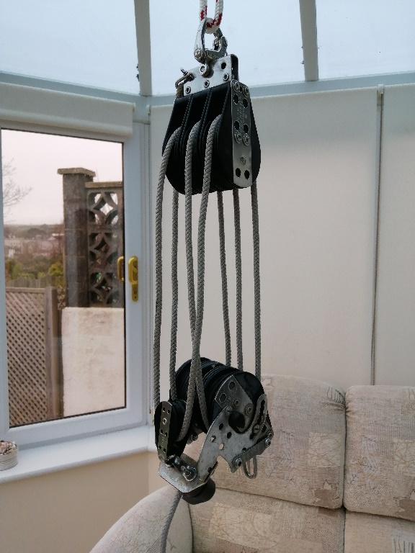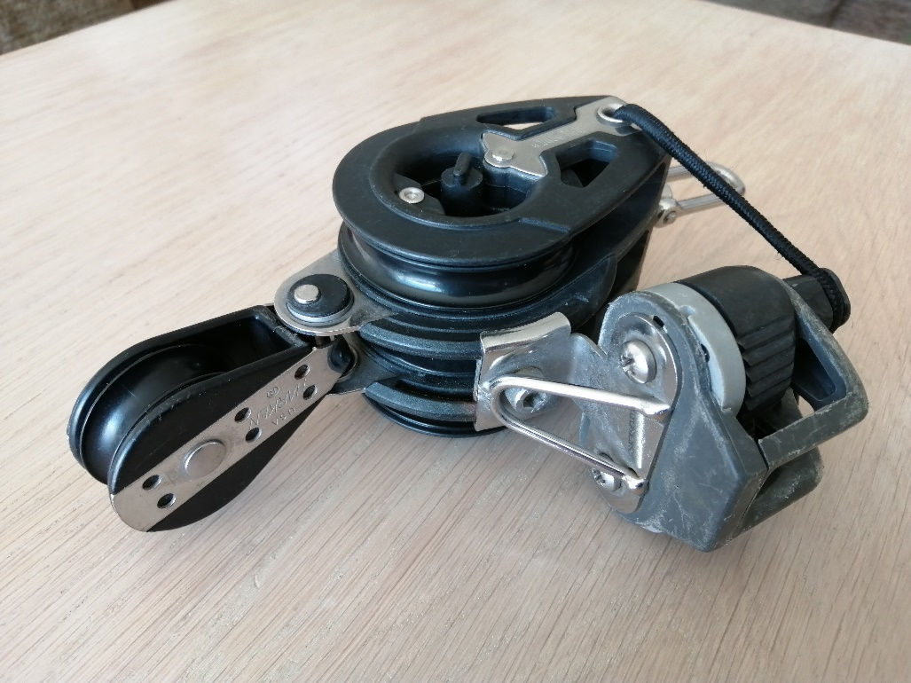
My original 7:1 Harken 76mm triple The 60mm triple Allen bottom block fitted with Harken 38mm
blocks top and bottom with a Harken above, which combined with an Allen triple 60mm top
38mm pulley and tapered sheet block gives a 7:1 purchase ratio

History
Having been a class measurer for over 50 years, and a background in engineering, I was in a unique position to use my knowledge and contacts to be able to test the various systems in use, to find out which is the best.

The original 7:1 system which was used from the inception of the Hurricane, uses the large Harken 76mm diameter pulleys top and bottom with an additional 38mm Harken pulley on the bottom mounted directly over the jammer.

In 2013, in order to make the Hurricane easier to sail, the class allowed the mainsheet purchase to be increased from 7:1 up to 9:1. Due to the cost of the new blocks, only a few boats changed to the new purchase. Over the winter of 2013/4, I was able to develop the original system with an additional pulley hung below the top 76mm block, change the lower single to a double and develop a low cost 9:1 system. The majority of Hurricanes now use this development.

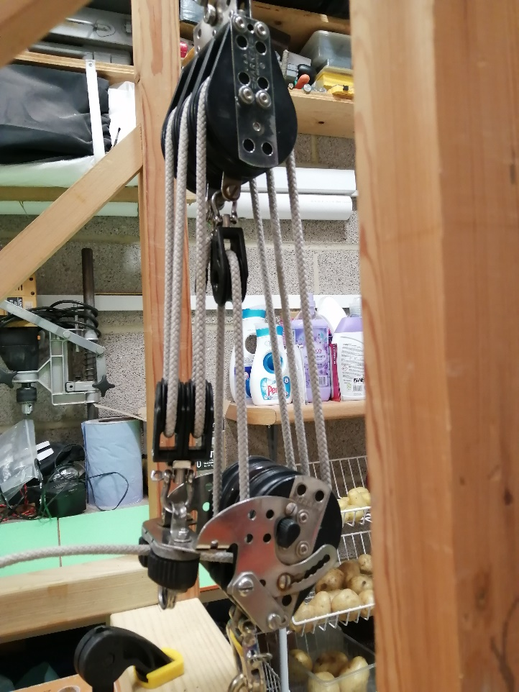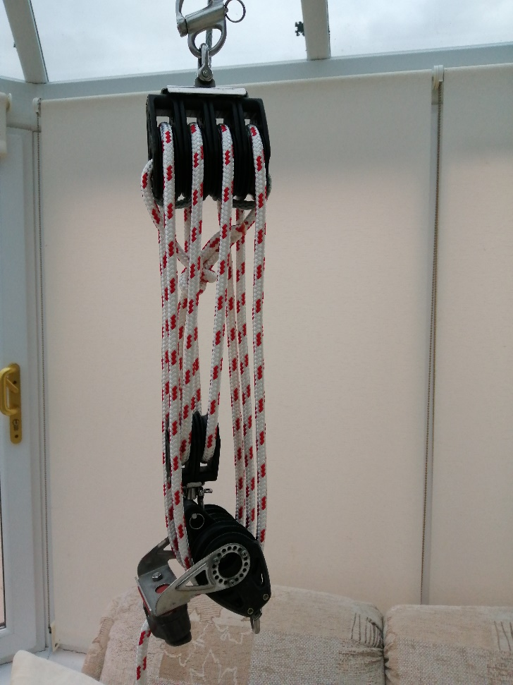
My 9:1 system on test. Harken 76mm triple pulley, 9:1 system with 57mm Harken quad pulley on top,
plus single 40mm pulley on top, 76mm Harken triple Harken triple 57mm pulley, rachet and double pulley, rachet and double 40mm pulley on bottom 40mm pulley on the bottom, with a 10mm sheet.
using a Robline 6.5mm to 9.5mm tapered sheet

Test Blocks
The following blocks were used in the tests, the first listed is the top block, the second the lower. During the tests, the ratchet on the bottom blocks was disengaged and the angle of the block adjusted so that the jammer was inoperative.
7:1 – the original purchase ratio.
Harken 76mm x 3, Harken 76mm x 3 + Harken 38mm x 1
Allen 60mm x 3, Allen 60mm x 3 + Harken 38mm x 1 – rigged with single block above triple.
Allen 60mm x 3, Allen 60mm x 3 + Harken 38mm x 1 – rigged as Harken Original with single block above jammer.
8:1 – not currently used, but legal, tested purely for information.
Harken 76mm x 3 + Harken 40mm x 1, Harken 76mm x 3 + Harken 38mm x 1
9:1 – maximum currently allowed under the rules.
Harken 76mm x 3 + Harken 40mm x 1, Harken 76mm x 3 +Harken 40mm x 2
Harken 57mm x 4, Harken 57mm x 3 + Harken 40mm x 2
Allen 60mm x 4, Allen 60mm x 5
10:1 – proposed new maximum.
Harken 76mm x 3 + Harken 40mm x 2, Harken 76mm x 3 + Harken 40mm x 2
Harken 57mm x 5, Allen 60mm x 3 + Allen 40mm x 2
Allen 60mm x 5, Allen 60mm x 5

Unfortunately the Harken original 76mm blocks are no longer in production. However Harken do currently make a 75mm range with up to 4 pulleys which could be used as the top block, the lower could be the Harken 75mm triple with the addition of a 40mm double. This system will give a 9:1 purchase, but it will not be possible to convert it to 10:1, so has not been tested.

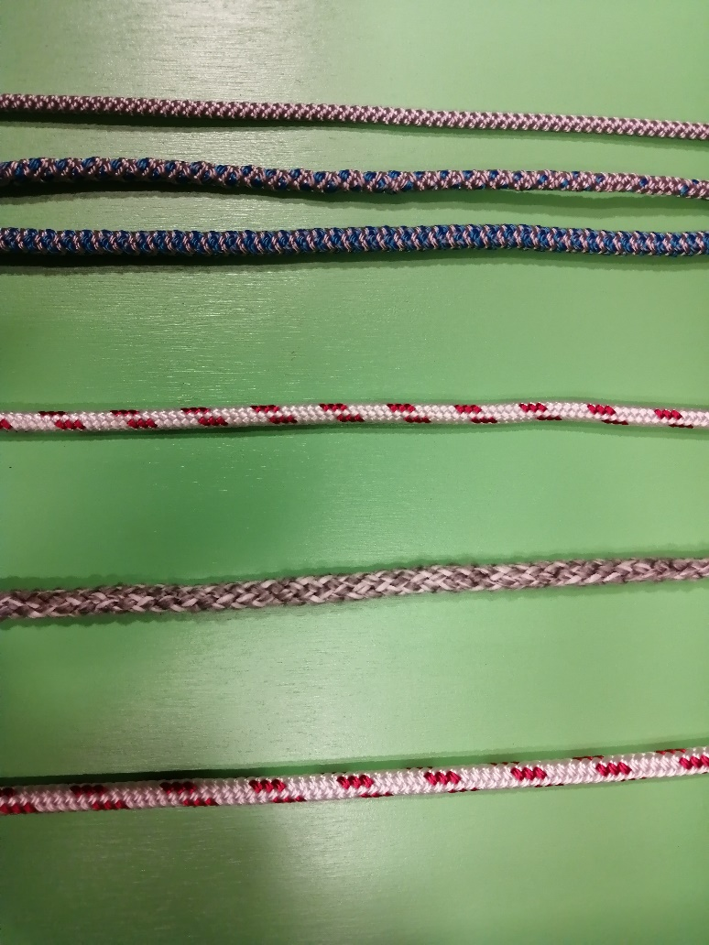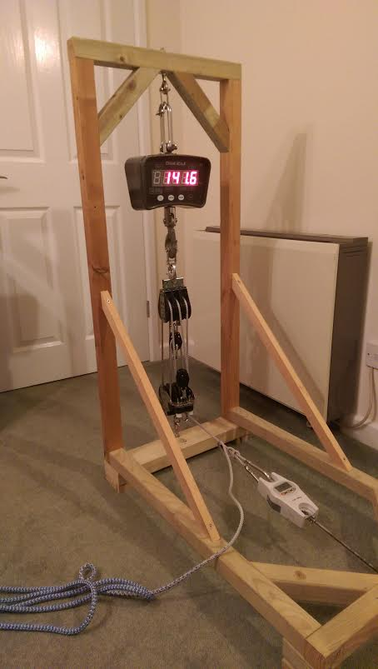

Robline Tapered Robline Orion 300 Used 8.0mm Robline Orion 300 Test Rig
6.5mm to 9.5mm 8mm-16 Plait 8 Plait 10mm-16 Plait
showing taper

Data
The accompanying Excel spread sheet ‘Main Sheet Calculations’ contains all the recorded data and is split into three sections. The last four sheets containing the word ‘Data’ are the individual readings for each purchase ratio, the preceding four sheets list the average sail loads for different sheet loads, with the efficiency; and he first sheet brings all the sail and sheet loads together for each of the purchase ratios for easy viewing.

Sheets Tested
Robline produce a tapered sheet, which I started using in 2014. The sheet tapers from 6.5mm diameter up to 9.5mm over a distance of 500mm – the 6.5mm diameter sheet works well in the ratchet, so is used around all the pulleys, experience has shown that anything smaller than 6.5mm will not hold in the ratchet. Also when sailing, the helm is holding the 9.5mm end which does make it much easier on the hands.

The other two Robline sheets were identical 16 plait in their makeup, the only difference being the diameters, so a direct comparison between the two is possible. The fourth sheet was taken from the 10:1 purchase sent by Andy Webb, this was a used 8 plait, and had a very soft feel, initially I thought it was a 10mm diameter, but as soon as it is loaded it reduces down to 8mm. I thought it would be useful to test a used soft feel 8mm sheet just to compare it against a new 8mm. As the two 8mm sheets give similar results, and the used 8 plait sheet was of unknown manufacture, they are not included in this report, but can be viewed in the spread sheet.

Sheet Load
The position of the blocks in the centre of the rear beam means that the more the helm pulls on the sheet the more they are pulled off balance, and as a rule of thumb, single handed you can only pull about half your body weight. So it is reasonable to assume that an average helm will be able to pull about 40kg; this was confirmed by tests on shore in the dinghy park. If the crew rather than the helm plays the main sheet with both hands, the pull will still be in the region of 40kg, due to the sheeting angle. So for analysis the results from a 40kg sheet load are the most realistic maximum that can be achieved when sailing, although the tests were taken up to 50kg for information.

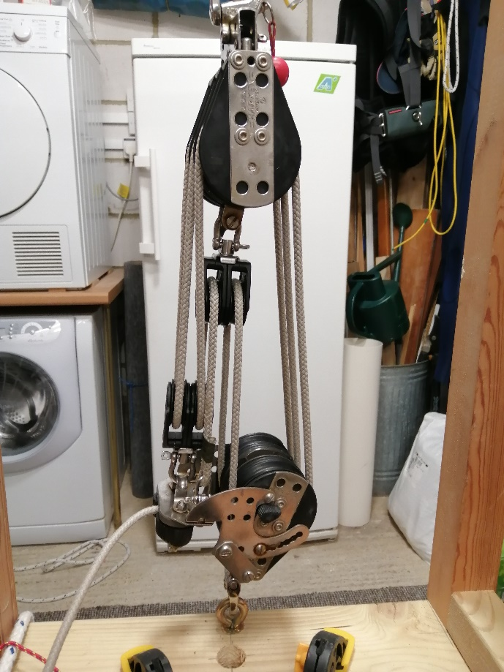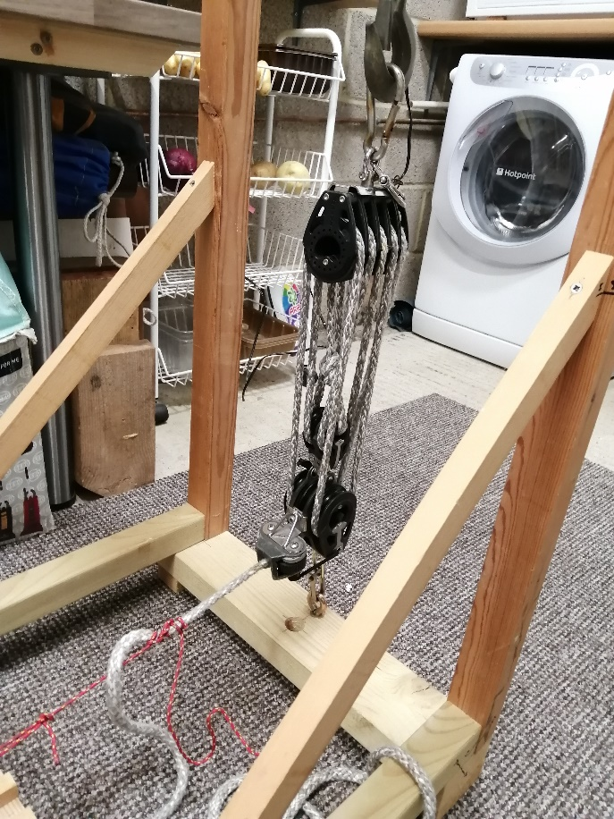
My original 7:1 modified to 10:1 New 10:1 with 57mm Harken block on top and Allen
With the Robline tapered sheet 60mm and double 40mm on bottom with 8mm used sheet

Results
10:1 Purchase.
There are three ways to get the 10:1 purchase. The first is to change the top single pulley on the modified original 76mm top bock for a double 40mm (same as on the lower block), a cheap and effective solution costing only about £80 – column 1 in table below. The second is to purchase second-hand blocks from someone giving up Formula 18 sailing, this will probably have a Harken 57mm diameter x 5 top block which is no longer available new – column 2. The third, is to purchase new an Allen Brothers A2169 & A2069 which have 5 x 60mm pulleys for both blocks giving a 10:1 system – column 3.

10:1 Ratio | Harken 76mm x 3 + 40mm x 2, Harken 76mm x 3 + 40mm x 2 |  |  | Harken 57mm Diameter x 5, Allen 60mm x 3 + 40mm x 2 |  |  | Allen 60mm Diameter x 5, Allen 60mm Diameter x 5
Sheet | 6.5mm | 8mm | 10mm | 6.5mm | 8mm | 10mm | 6.5mm | 8mm | 10mm
10kg | 69.6 | 61.8 | 54.0 | 59.7 | 56.7 | 47.5 | 75.6 | 62.0 | 60.8
15kg | 101.7 | 92.2 | 81.8 | 95.1 | 86.2 | 72.7 | 113.0 | 94.0 | 90.4
20kg | 136.2 | 120.9 | 107.7 | 127.4 | 116.7 | 98.9 | 150.2 | 124.4 | 120.4
25kg | 170.1 | 152.2 | 135.0 | 162.1 | 145.9 | 123.1 | 185.4 | 153.8 | 149.7
30kg | 202.7 | 179.5 | 158.9 | 194.4 | 174.3 | 148.5 | 219.8 | 184.1 | 176.7
35kg | 229.4 | 207.4 | 184.6 | 226.6 | 201.3 | 171.0 | 256.7 | 212.1 | 201.7
40kg | 260.7 | 232.2 | 212.7 | 254.3 | 230.4 | 192.7 | 286.7 | 238.5 | 225.6

9:1 Purchase.
Most of the Hurricanes use the modified system where an additional 40mm pulley has been hung below the top Harken block and the lower changed to a 40mm double – see column 1 in table below. Some who wanted to change quickly purchased a Harken 57mm x 4 block and a Harken 57mm x 3, together with a 40mm double – column 2. Column 3 is the new Allen 60mm x 4 on top and an Allen 60mm x 5 on the bottom.

9:1 Ratio | Harken 76mm x 3 + 40mm x 1, Harken 76mm x 3 + 40mm x 2 |  |  | Harken 57mm Diameter x 4, Harken 57mm x 3 + 40mm x 2 |  |  | Allen 60mm Diameter x 4, Allen 60mm Diameter x 5
Sheet | 6.5mm | 8mm | 10mm | 6.5mm | 8mm | 10mm | 6.5mm | 8mm | 10mm
10kg | 63.9 | 57.5 | 53.1 | 56.6 | 54.2 | 51.3 | 67.5 | 56.1 | 56.0
15kg | 95.4 | 86.8 | 79.3 | 87.1 | 80.1 | 75.6 | 103.4 | 85.7 | 83.8
20kg | 126.2 | 114.1 | 106.4 | 117.9 | 106.2 | 101.4 | 135.7 | 115.4 | 111.0
25kg | 155.8 | 142.0 | 131.3 | 146.2 | 129.8 | 126.8 | 169.0 | 142.3 | 139.0
30kg | 185.4 | 168.7 | 156.4 | 171.7 | 153.8 | 148.5 | 201.7 | 170.3 | 167.5
35kg | 215.1 | 194.4 | 180.7 | 200.0 | 175.4 | 170.2 | 232.7 | 197.3 | 190.8
40kg | 241.3 | 221.2 | 202.8 | 221.9 | 195.6 | 190.9 | 264.6 | 222.4 | 213.4

8:1 Purchase
The results for the 8:1 purchase ratio can be viewed in the Excel Spread Sheet; these are not in common use so are ignored for this report.

7:1 Purchase.
This is the original system that all Hurricanes had – column 1 below. Column 2 with the Allen 60mm blocks is the closest currently available.
The Allen blocks rigged as the original Harken blocks where the single extra pulley was mounted on top of the jammer were tested, but as the results were not as good as the block directly on top of the lower block they are ignored. If wished, the results can be viewed on the spread sheet.

7:1 Ratio | Harken 76mm Diameter x 3, Harken 76mm x 3 + 40mm x 1 |  |  | Allen 60mm Diameter x 3, Allen 60mm x 3 + Harken 38mm x 1
Sheet | 6.5mm | 8mm | 10mm | 6.5mm | 8mm | 10mm
10kg | 53.8 | 48.1 | 49.5 | 55.5 | 49.7 | 46.5
15kg | 80.9 | 70.8 | 72.2 | 85.2 | 73.6 | 69.7
20kg | 106.3 | 94.3 | 93.3 | 110.9 | 99.3 | 91.8
25kg | 130.7 | 116.9 | 116.6 | 143.1 | 123.3 | 117.3
30kg | 160.4 | 139.0 | 138.3 | 167.0 | 146.0 | 138.5
35kg | 184.4 | 161.9 | 158.3 | 190.4 | 168.7 | 158.7
40kg | 206.5 | 184.6 | 177.7 | 219.8 | 188.5 | 181.1

Sailing In the Real World
I picked the most difficult conditions to try the 10:1 modified original, with the two extra 40mm pulleys. It was a typical Starcross easterly, quite windy with gusts up to about 28 knots, with the wind direction varying by about 20 degrees. Not the ideal conditions to try out a new system.
My first impressions were that although it had the extra purchase over my usual 9:1, it did not feel any more powerful, but I did not like the extra sheet length. Also when dumping the main, it took that extra split second to release.
I realise that these were not ideal conditions, in open water you would not have to deal with gusts coming from different angles, just the extra sheet length, which always seems to find a way either around your feet or over the rear beam. So I will be staying with my 9:1 with a tapered sheet.

Conclusions
Over nineteen and a half thousand readings were taken, and the results averaged to give reliable figures. Clearly the efficiency depends on three criteria;
- The diameter of the sheet,
- The number of pulleys and
- Their diameters.

All the tables indicate that the 6.5mm diameter sheet has a clear advantage over the larger diameters due to the reduction in frictional losses.

With the 10:1 ratio, clearly the Allen 60mm blocks do have an advantage over the other systems which are restricted by the addition of the smaller pulleys, and if money was no problem, would be the way to go. It is worth pointing out however, the modified original with a 6.5mm tapered sheet, is second only to the Allen 60 mm blocks again with the same sheet.

The 9:1 table shows again the efficiency of the modified original with the 6.5mm sheet; only the Allen 60mm blocks with the 6.5mm sheet are better. However, the modified original with 9:1 ratio and a 6.5mm sheet is better than the 10:1 Harken 57mm with any sheet diameter and better than 10:1 Allen 60mm with either the 8mm or 10mm sheets. Sheet choice is vitally important.

Since Harken stopped the original 76mm pulleys, we have not had a viable alternative should someone require a 7:1 purchase. We do now, with the Allen 60mm blocks, as they both have a very similar performance to the original.

In summary the following observations and recommendations are made;
- Both the modified 7:1 Harken and the Allen 60mm with the 10:1 purchase ratio have an advantage over their 9:1 systems by approximately 8%. However, a disadvantage of the 11% increase in purchase ratio is that it requires 11% more sheet which can be more difficult to handle and slower to dump.
- In both 9:1 and 10:1, the Allen 60mm blocks are approximately 11% more efficient than the Harken systems.
- The systems which include the Harken 57mm diameter blocks are not recommended as they are less efficient and more expensive than converting the original Harken 76mm blocks.
- An important test will be how good the 10:1 is in the real world, considering the increase in length of sheet, and how quickly the main can be dumped in a gust. This will only become apparent with more testing on the water.
- The 10:1 converted original 7:1 is available for anyone to try. For those participating helms, their feedback to Committee should be encouraged so that an informed decision on the introduction of the 10:1 purchase ratio can then be made in 2022.

Thanks to :-
The ‘Salcombe Yawl Owners’ Association’ for the use of their crane scales.
ProBoat, for supplying the Allen 60mm x 5 lower block, Allen 60mm x 5 and Allen 60mm x 4 top blocks, all without charge.
Doug Smith, for letting me convert his old 7:1 original into a 10:1 for the fleet to try.
Andy Webb, for supplying the used ex-Formula 18, 10:1 system to test and a tapered main sheet for Doug’s 10:1.

